**Just in Time Spanish Essentials - Time**

**Introduction**

**Time**

Here you can see at a glance the Spanish key language related to time: asking and giving the time, digital time using the 24-hours, saying parts of the day and asking for information about what happens when.

**Saying what time it is - on the hour**

To find out what the time is, you may say

**¿Qué hora es? - What time is it?**

To reply, you must think in the number of hours. Yes. If you are talking about ‘1:00’ and any time related to ‘1:00’ you must start your answer with ‘es la …..(una)’ but from ‘2-12’ you use the plural from of the verb and say ‘son las ….’ followed by a number to say the time on the hour.

For example:

¿Qué hora es? - What time is it?

Son las dos - It is two o’clock.

However, for one o’clock use es ‘la’ instead of son ‘las’.

¿Qué hora es? - What time is it?

Es la una - It is one o’clock.

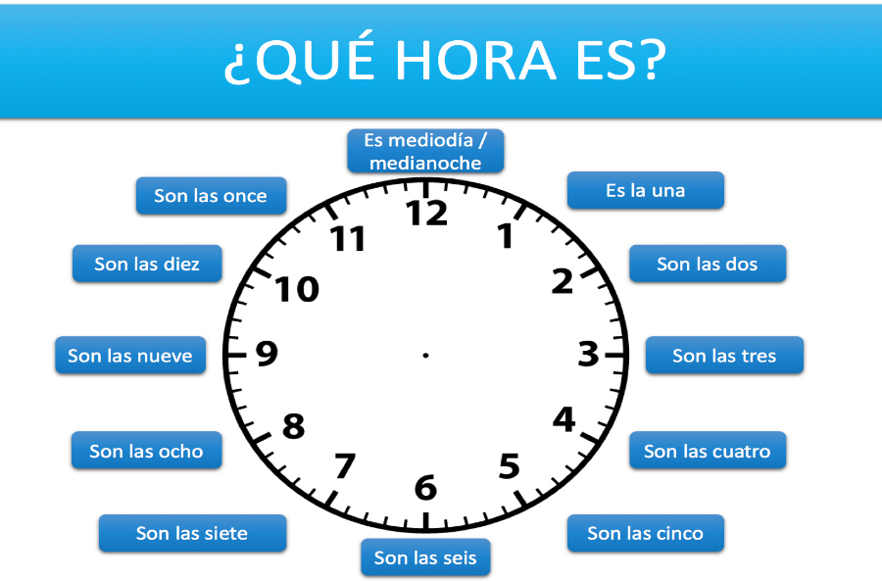

**Telling the time: asking and giving the time - the exact hour and more**

Listen to people talking about the time by clicking on the clocks. **ADD AUDIOS and design the graphics to get this clocks/times**

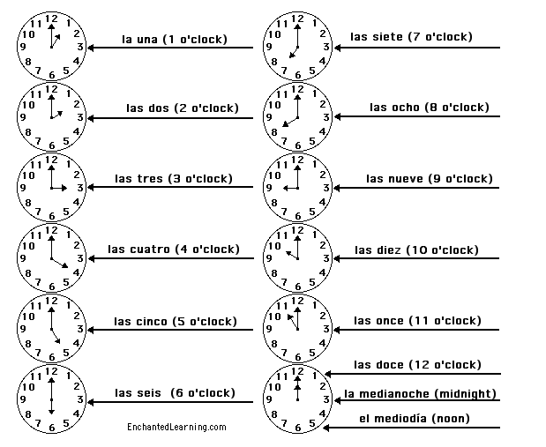

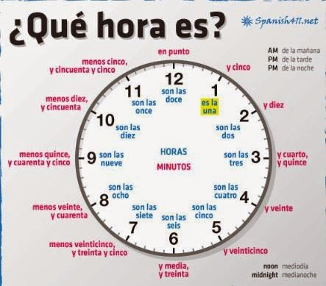

**Telling the time: asking and giving the time (the minutes) II**

**Saying what time it is - in five minute increments**

To say minutes past the hour just say the hour and add ‘y’ followed by the number of minutes after the hour.

Spanish English

y cinco five past

y diez ten past

y veinte twenty past

y veinticinco twenty-five past

When you want to say the minutes before the hour. You must start with the original formula:

Es/son la/s -----(use the next hour) menos ------------- (the number of minutes before to the hour)

menos cinco five to

menos diez ten to

menos veinte twenty to

menos veinticinco twenty-five to

**For example:**

Son las nueve y diez - It is ten past nine.

Es la una menos veinte - It is twenty to one.

**Saying what time it is and the part of the day - in the morning, the afternoon and the evening**

In Spain, people often say ‘de la mañana’ (in the morning), ‘de la tarde’ (in the afternoon, from 13:00 until 18:00), and ‘de la noche’ (in the the evening, from when it gets dark until midnight).

For example: **AUDIO and ICONS**

Son las ocho de la mañana - It’s eight o'clock in the morning.

Son las tres y media de la tarde - It’s half past three in the afternoon.

Son las nueve y cuarto de la noche - It’s quarter past nine in the evening.

**Parts of the day: Saying parts of the day I**

Listen to people telling time from different parts of the day by clicking on the audio icons. The key language is summarised in this table.

saying parts of the day

“Son las diez de la mañana” it’s ten o’clock in the morning

“Son las cuatro de la tarde” it’s four o’clock in the afternoon

“Son las siete de la noche” it’s seven o’clock in the evening

“Son las dos de la manana” it’s two o’clock in the morning

“Es (la) medianoche” it’s midnight

“Es (el) mediodía” it’s midday

**Saying what time it is - the 24 hour clock**

You may find that the 24 hour clock is used for timetables, television or film listings or hours that a shop is open.

For example:

Son las trece quince - It's 13:15.

Son las diecisiete treinta - It's 17:30.

Son las veintiuna cuarenta y cinco - It's 21:45.

Son las cero diez - It's 00:10.

14:10 son las catorce y diez (fourteen ten)

20:55 son las veinte y cincuenta y cinco (eight fiftyfive)

00:00 las venticuatro (twenty four)

**Know-how:**

This way of giving the time is used for public information (e.g. train timetables) and formal appointments.

**Saying at what time things happen**

Use ‘**a las**’ + the time to say when something happens.

For example: **(AUDIOS AND ICONS)**

Desayuno a las siete - I have breakfast at seven o'clock.

Ceno a las seis y media - I have dinner at half past six.

Almuerzo a la una y media - I eat at half past one.

**Describing daily routine**

To describe what you do during the day and at what time, you may need to use some ***reflexive verbs***.

A reflexive verb is one where the subject and object are the same, and where the action ‘reflects back’ on the subject. It is used with a reflexive pronoun such as myself, yourself and herself in English, for example,I washed myself.; He shaved himself.

For example: **(AUDIOS- ICONS)**

Me levanto a las ocho menos cuarto - I get up at quarter to eight.

Me lavo a las ocho - I get washed at eight o'clock.

Me acuesto a las nueve y media - I go to bed at half past nine.

Voy al colegio a las ocho menos cuarto - I go to school at quarter to eight.

Llego a casa a las tres y media - I get home at half past three.

Juego al fútbol en el parque a las cinco - I play football in the park at five o'clock.

PRACTICE

Listen to people asking and giving the time by clicking on the audio icons. The key language is summarised in the table.

asking the time giving the time

Qué hora es? Es la una y media de la tarde.

What time is it? It is 1:30 pm

A qué hora es….? A las cuatro de la tarde.

When (At what time) is……? At four o’clock p.m.

¿A qué hora es el concierto? Es a las nueve y media de la noche

What time is the concert? It’s at half past nine in the evening.

¿A qué hora se sirve el desayuno? El desayuno se sirve de siete a nueve de

la mañana.

What time is the breakfast? Breakfast is served from seven to nine.

¿A qué hora es el almuerzo? El almuerzo es a la una de la tarde.

What time is the lunch? The lunch is at 1PM

¿A qué hora sale el tren? El tren sale a las dieciocho y cincuenta

What time does the train leave? The train leaves at 18.50

¿A qué hora llega el tren? El tren llega a las catorce y veinte

What time does the train arrive? The train arrives at 14.20

¿A qué hora abre el banco? El banco abre a las nueve de la mañana.

What time does the bank open? The bank opens at 9.00 AM

¿A qué hora cierra el banco? El banco cierra a las ocho de la noche.

What time does the bank close? The bank closes at 8.00 PM

¿A qué hora empieza la película? La película empieza a las cuatro y cuarto

What time does the movie start? The movie starts a quarter past four.

¿A qué hora termina la película? La película termina a la seis y media.

What time does the movie finish? The movie finishes at half past six

**DRAG AND DROP** – Match the correct time by dragging the expression to the clocks. If the answer is correct, the audio will play.

Hide column Hide column

**IMAGES OF CLOCKS**

07:15 Son las siete y quince

09:20 Son las nueve y veinte

10:30 Son las diez y treinta

13:30 las trece y treinta

12:45 Es la una menos quince